VIETNAM-KOREA UNIVERSITY OF INFORMATION AND  
COMMUNICATION TECHNOLOGY

Faculty of Computer Science



GRADUATION THESIS

TOPIC: BUILDING SYSTEM

FACE RECOGNITION SUPPORTS ATTENDANCE

Student: HO HOANG NAM

Class: 23IT1

Supervisor: DR. LE HOAI AN

Da Nang, September – 2023

VIETNAM-KOREA UNIVERSITY OF INFORMATION AND

COMMUNICATION TECHNOLOGY

Faculty of Computer Science

GRADUATION THESIS

TOPIC: BUILDING SYSTEM

FACE RECOGNITION SUPPORTS ATTENDANCE

Student: HO HOANG NAM

Class: 23IT1

Supervisor: DR. LE HOAI AN

Da Nang, September - 2023

SUPERVISOR’S COMMENT

………………………………………………………………………………………………………………………………………………………………………………………………………………………………………………………

………………………………………………………………………………………………………………………………………………………………………………………………………………………………………………………

………………………………………………………………………………………………………………………………………………………………………………………………………………………………………………………

………………………………………………………………………………………………………………………………………………………………………………………………………………………………………………………

………………………………………………………………………………………………………………………………………………………………………………………………………………………………………………………

ACKNOWLEDGEMENTS

We would like to profoundly acknowledge the people who have helped me during my studies:

First of all, We would like to sincerely thank the teachers of the Computer Science Department, Vietnam-Korea University of Information and Communication Technology

We would like to thank supervisor Dr. Le Hoai An in the past time has helped us in completing the graduation thesis.

STATEMENT OF AUTHORSHIP

………………………………………………………………………………………………………………………………………………………………………………………………………………………………………………………

………………………………………………………………………………………………………………………………………………………………………………………………………………………………………………………

………………………………………………………………………………………………………………………………………………………………………………………………………………………………………………………

………………………………………………………………………………………………………………………………………………………………………………………………………………………………………………………

………………………………………………………………………………………………………………………………………………………………………………………………………………………………………………………

Danang, September 17th, 2023

TABLE OF CONTENTS

ABBREVIATIONS

|  |  |
| --- | --- |
| ABBREVIATIONS | MEANING |
| MTCNN | Multi-task cascaded convolutional neural networks |
| NN | Neural networks |
| VGA | Video Graphics Adaptor |
| OOP | Object Oriented Programming |
| Colab | Collaborators |
| FCNN | Full Convolution Neural Network |

LIST OF FIGURES

LIST OF TABLES

INTRODUCTION

Problem statement

Information technology has an increasingly important role in economic, social, cultural and political development and contributes to the formation of new people. Currently, Vietnam's information technology industry is still in a state of slow development compared to other countries in the world and in the region. The application of information technology has not yet met the requirements of the industrialization and modernization of the country and the requirements of regional and international integration.

A common image when using a timekeeper is a long line of people waiting for timekeeping in front of the office. Of course, this is not a problem when the business is small, but when the employees are overcrowded and focused on timekeeping at the same time, it will be a really "annoying" problem for both employees and managers.

Aims and Objectives

The purpose of the topic Face recognition support attendance is to help businesses, companies and schools to take attendance and timekeeping quickly, accurately and safely.

Structure of the thesis

After the Introduction, the thesis is structured in three chapters:

Chapter 1, Topic overview

In this chapter, the thesis presents an overview of the topic, introduces the system, benefits for users and managers, limitations of the project, points out solutions to implement the topic and points out existing systems. In addition, this chapter also presents the theoretical basis, languages ​​and tools to implement the topic.

Chapter 2, System analysis and design

This chapter includes the analysis and design to build the topic, this chapter presents the scope of the topic, analyze the target audience of the system, functions to be included in the system, user requirements, use-case description, use-case diagram, class diagram, sequence diagram, activity diagram and database.

Chapter 3, Implementation of building system

This chapter presents the overview model of the system, detailed design and system building process.

Finally, there are Conclusions, Suggestions, References and Appendices related to the topic.

TOPIC OVERVIEW

Face recognition system

The camera system is increasingly developed, the identification technology is getting more and more accurate, and the device works optimally and efficiently.

The demand for automating timekeeping in schools, agencies, factories, construction sites, production facilities ... is increasingly focused.

Face recognition system, time attendance support is designed and developed with many features, simple installation, user-friendly interface. Flexible management system, very convenient for operators and managers.

Benefits of face recognition system

For timekeeping subjects

Timekeepers only need to put their face into the camera to take attendance and timekeeping without having to do other operations.

Timekeepers do not spend much time waiting. The operation process is quick and accurate, convenient.

The information about the face, personal information is more secure.

For manager

Save management costs.

Reduce the cost of hiring timekeepers.

Reduce the cost of loss risk because all transactions are stored on the software. Save time because the system works automatically.

Manage employees, departments easily.

Attendance activities will be recorded in time, avoiding problems.

Solution

A facial recognition system is a computer application that automatically identifies or identifies a person through facial features, the system will rely on data received from a camera or video to compare with face database for comparison.

Besides, if the system has a problem with the user's not activating their faces, the user can use the web to make a public display.

Existing systems

Existing similar systems: Currently, there are many famous facial recognition systems such as online time attendance software using FaceID of FastWork, GlobalTech, ...

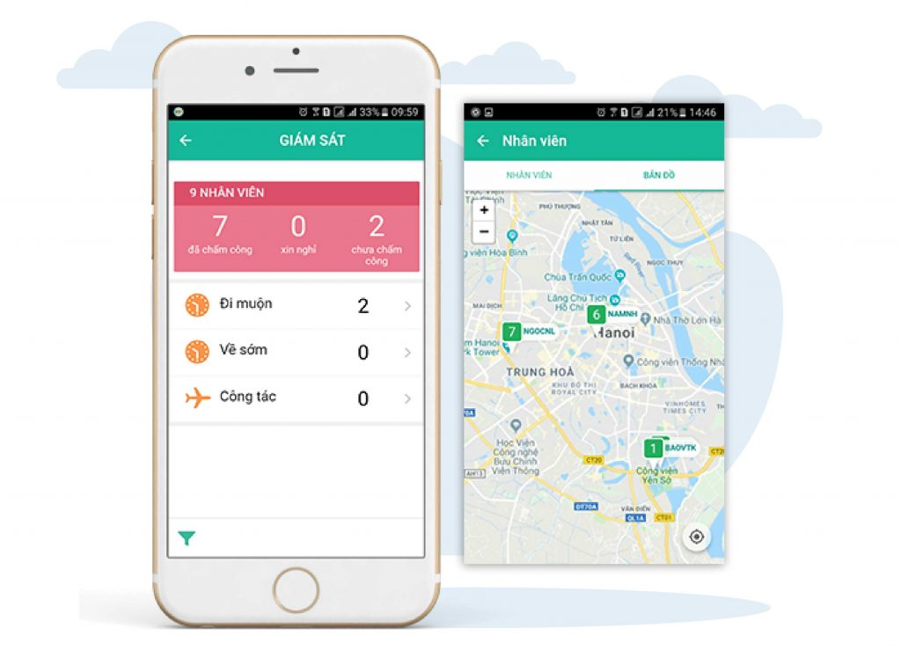

Figure . – Online attendance software with FaceID of FastWork

Fast recognition speed: with VGA image size (640×480) the recognition speed is 40-100ms. Recognized with Mega Pixel image size (1280 x 960) with recognition speed from 70-200ms

Restrictions

Face recognition is not perfect and difficult to perform under certain conditions. Ralph Gross, a researcher at the Carnegie Mellon Robotics Institute, describes an obstacle related to facial viewing angles: "Face recognition performed quite well on the front side and the 20-degree difference side, but as soon as you go into the corner, there's a problem."

Other conditions where facial recognition does not work well include low light, wearing sunglasses, long hair, or other subjects where part of the face is covered, and low resolution images.

Comment

Based on organizational benefits and solutions, we need an application that is closest to the user, with the best image quality, security, safety and stability in the transmission.

Theoretical basis

Using Pycharm software

Concept:

PyCharm is a cross-platform integrated development environment (IDE) developed by Jet Brains and specifically designed for Python. PyCharm is available on all 3 platforms Windows, Linux and Mac OS.

Using Visual Studio Code

Concept:

Visual Studio Code is a coder editor developed by Microsoft reserved for Windows, Linux and macOS. It supports debug function, accommodates Git, with syntax highlighting itself, completes the clever code, snippets, and improve the source code. It also allows tune, so the user can change theme, keyboard shortcut, and other options. It's free and it’s open-source code software, even if it's downloaded, there's a license.



Figure . – Visual Studio Code Interface

Python



Figure . – Python logo

Concept:

Python is a powerful, high-level, object-oriented programming language, created by Guido van Rossum. It's easy to learn and is emerging as one of the best introductory programming languages ​​for first-timers. Python is completely dynamically typed and uses automatic memory allocation. Python has powerful high-level data structures and a simple yet effective approach to object-oriented programming. Python's command syntax is a huge plus as its clarity, ease of understanding, and flexible typing make it quickly an ideal language for scripting and application development in a wide variety of fields, in most areas. all platforms.

Summary

In this chapter, we have acquired basic knowledge to build systems such as programming tools, programming languages, and libraries and frameworks. Understand the concepts, definitions, advantages and disadvantages of each tool, language, mode of operation and mechanism of algorithms.

SYSTEM ANALYSIS AND DESIGN

Scope

Building and perfecting the face recognition system to conduct time attendance with an easy software interface for managers to facilitate attendance, timekeeping and management of people entering/exiting the company, facility offices, factories, and schools. Along with that is a backend system that handles the input data identified and saved in the database, which administrators can manage through the website to make attendance easier.

System functionalities

Get face recognition to train through the website

Automatic attendance when putting faces into the camera

Attendance history

Attendance checkout manual through website user in the attendance history

User can view total work hours and salary

Enter employee/personal information system

Use-case Diagram

Figure 2.1 below is the general use case diagram of the system

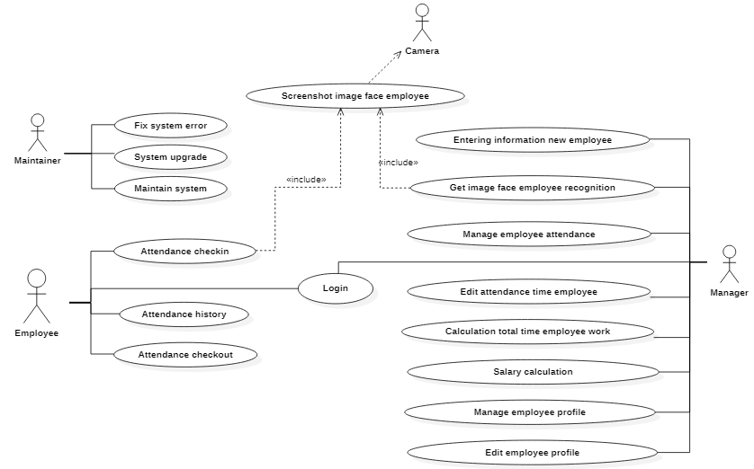

Figure . – Use-case diagram general

Figure 2.2 below is the detailed use case diagram of the actor employee

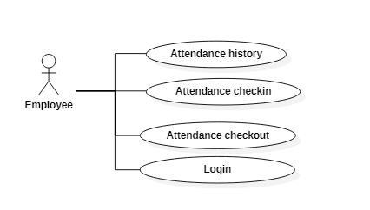

Figure . – Use-case diagram employee attendance

Description Use-case

For personal attendance

Table 2.1 below describes the detailed use case of attendance check in of the actor employee

|  |  |
| --- | --- |
| Use-case Name | Attendance check in |
| Actor | Personal attendance |
| Description | Helping employees/individuals to time attendance through facial recognition |
| Pre-Condition | Image face |
| Post-Condition | Attendance successful |
| Alternative Flows | 1. Face detection extracts images from the camera  2. The system process image and recognition face  3. Save the information of the face employee face used to get into the database |

Table . – Use-case Attendance check in

Table 2.2 below describes the detailed use case of attendance checkout of the actor employee

|  |  |
| --- | --- |
| Use-case Name | Attendance checkout |
| Actor | Personal attendance |
| Description | Helping employees/individuals to attendance manual checkout with part-time employee |
| Pre-Condition | Time present |
| Post-Condition | Attendance checkout successful |
| Alternative Flows | 1. Get time present  2. Request to server the time checkout and format it  3. Update time checkout attendance in the database |

Table . – Use-case Attendance check out

Class Diagram

Figure 2.3 below is the general class diagram of the system

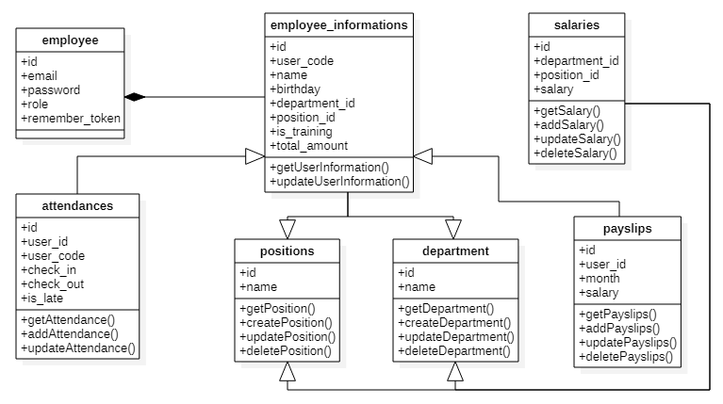

Figure . – Class diagram of system

Sequence diagram

Figure 2.4 below is the sequence diagram of the login account of user in the system

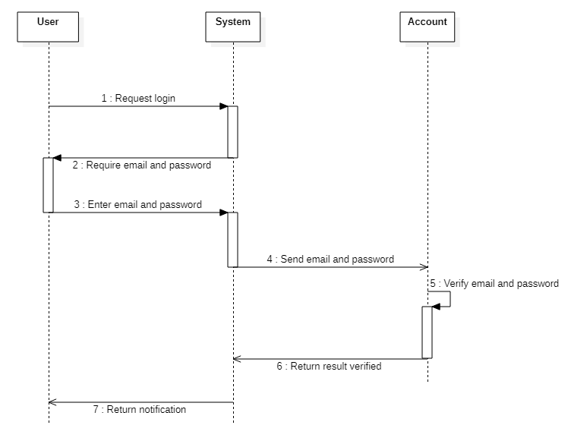

Figure . – Sequence diagram login account

Activity diagram

Figure 2.5 below is the activity diagram about recognition face of the user when attendance in system

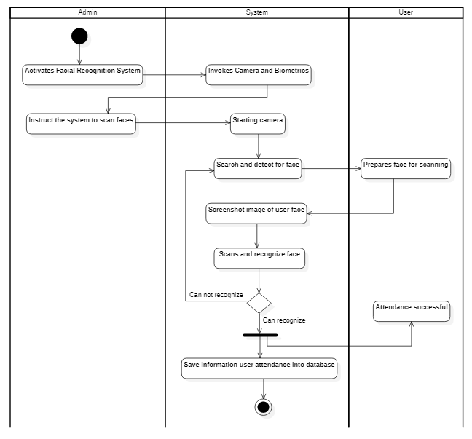

Figure . – Activity diagram recognition face user

Database

Tables in database

Table 2.3 below is a detailed description of the field of the user account table in database

Table . – Database user account

|  |  |  |  |
| --- | --- | --- | --- |
| Field | Type | Constraint | Description |
| id | BigInt | Primary key | Identify |
| email | Varchar | Not null | Email user account |
| email_verified_at | Timestamps | Null | Check email verified |
| password | Varchar | Not null | Password user account |
| role | Int | Not null | Role of user in system (Ex: admin, user,..) |
| remember_token | Vachar | Null | Access token user login |
| created_at | Timestamps | Null | Date time record create |
| updated_at | Timestamps | Null | Date time the last time record update |
| deleted_at | Timestamps | Null | Date time the last time record delete |

Database relationship

Figure 2.6 is an overview of the database as well as the relationships between the tables in the database

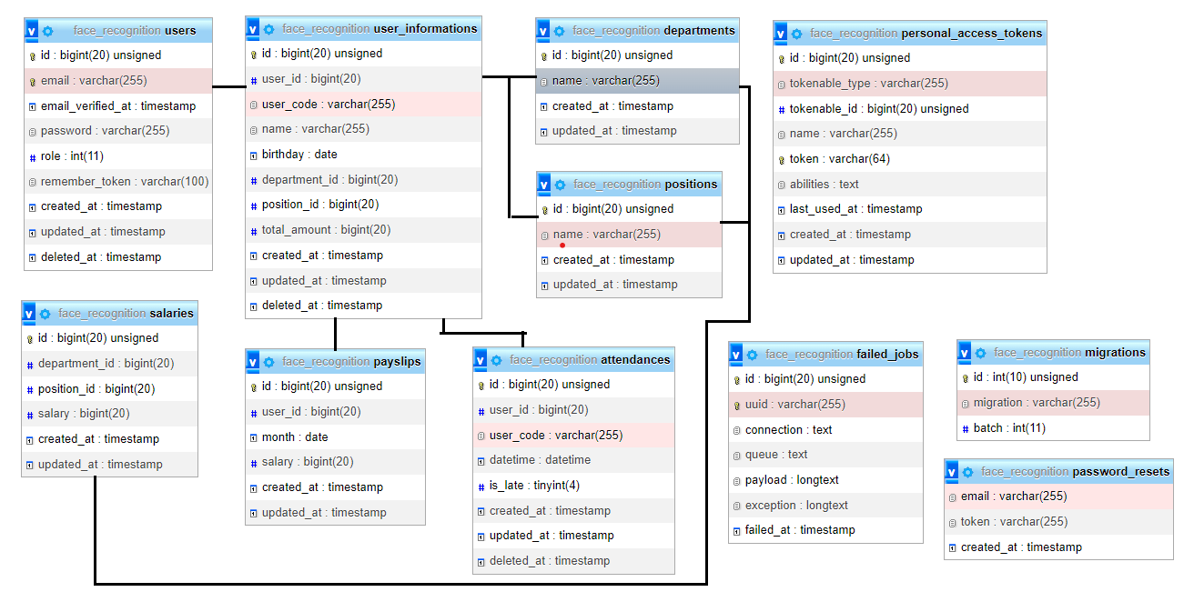

Figure . – Database relationship

IMPLEMENTATION OF BUILDING SYSTEM

Overview model of the system

Figure 3.1 - shows the flowchart of the face recognition steps. To do face recognition, there must be an input to be detected and verified. Hence, an image sensor or typically a camera has to be set up for recording or capturing images. The camera should be compatible with the software used. The next step is the input image. The input can be images and recorded video or real-time video. After the input is provided, faces in the images or videos are to be detected. When the classifier is trained, it can be utilized to start to recognition work. It can be used in either video or image to recognize one or more person. Different set of python scripts are provided to run the different type of recognition. The python script will import the classifier that is trained in previous step in order to carry out the recognition for the person from the camera or from an image.

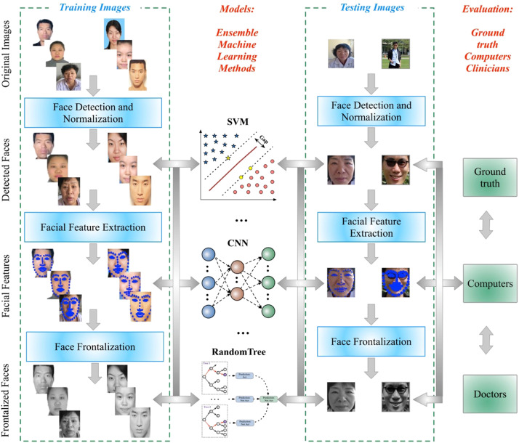

Figure . – Overview model of the system

Recognition algorithms

Step to build an algorithms

Step 1: Face detection

The camera detects and locates an image of a subject's face. Then record the image of the object.

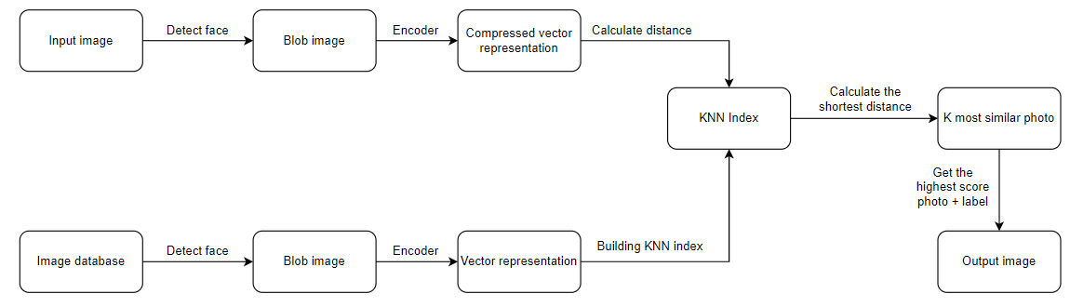

Figure . – Step to build an algorithm

Learning similarity

This method is based on a measurement of the distance between two images, usually the standard norm l1 or l2 such that if two pictures belong to the same person, the distance is minimal and if not, the distance is larger.

The key point is to build an encoding model that is good enough to project the images onto an n-dimensional Euclidean space. Then use the distance to decide their labels.

Facenet

Concept

Most of the pre-facenet face recognition algorithms try to represent the face with an embedding vector through a bottle neck layer which has the effect of reducing the data dimensionality.

Detail analysis of system

In Figure 3.5 is the face training screen interface that supports face recognition timekeeping, the left side is the screen extracted from the real time webcam and the right side is the display area of the mold images staff face, there are 2 buttons, snapshot and submit

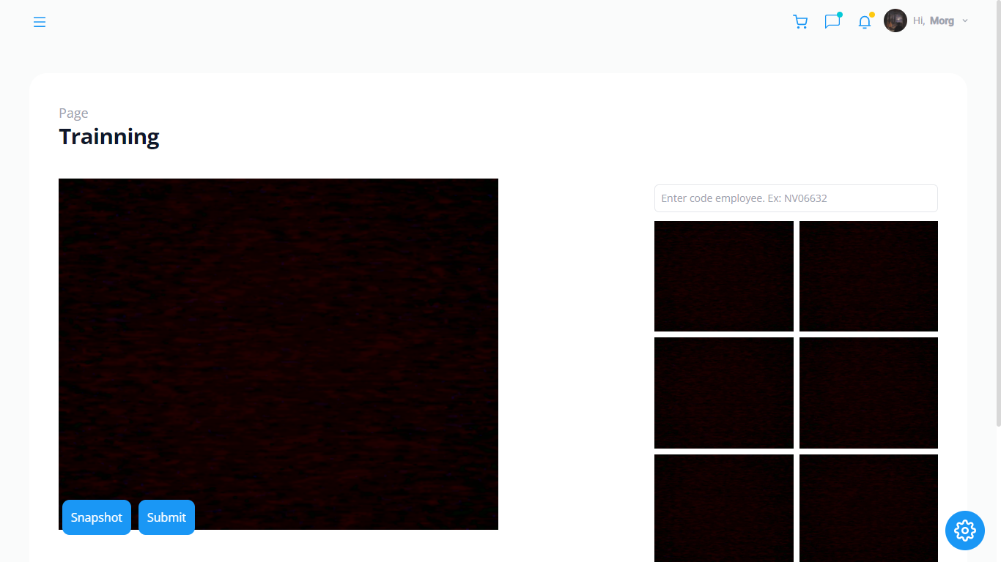

Figure . – UI about training face recognition

System building process

Building face training and recognition admin screen using ReactJS

Import library and component for this UI

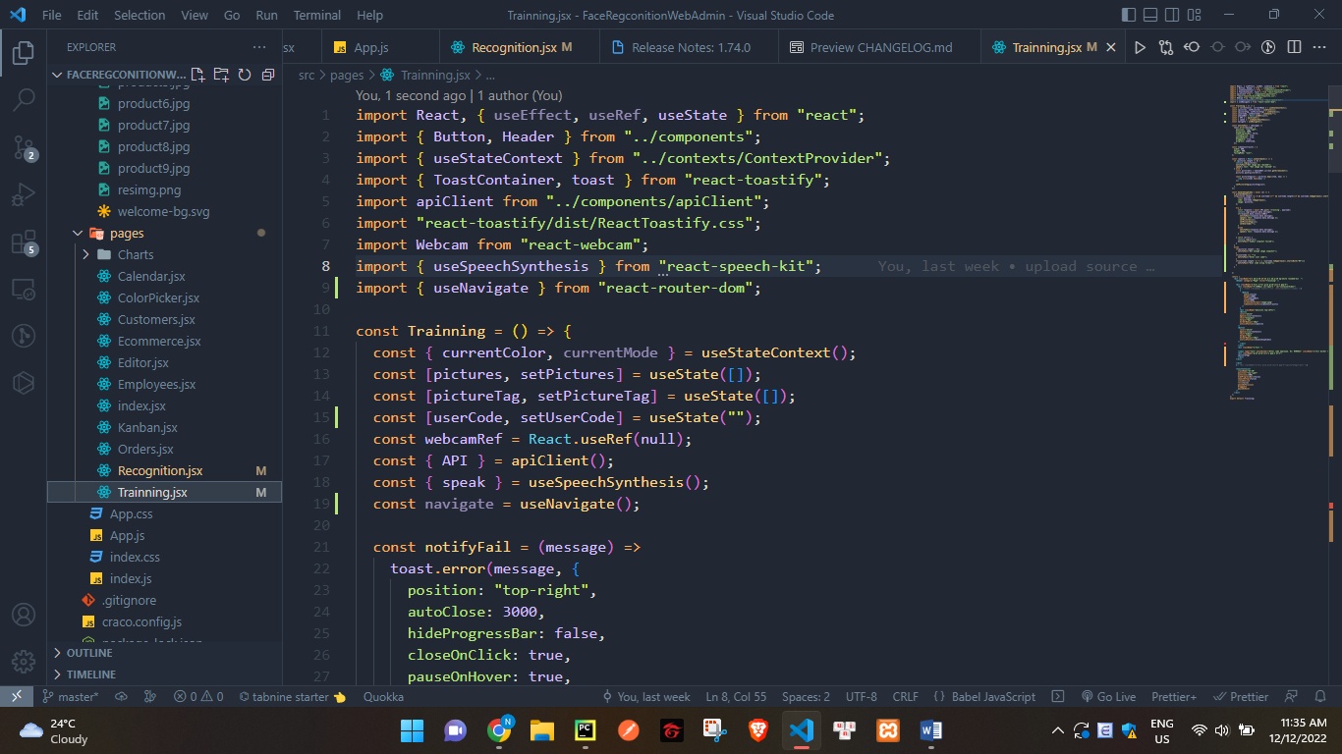

Figure . – UI face training and recognition ReactJS

Building User interfaces

In Figure 3.5 is the homepage interface of the system built by ReactJS and Tailwind CSS.

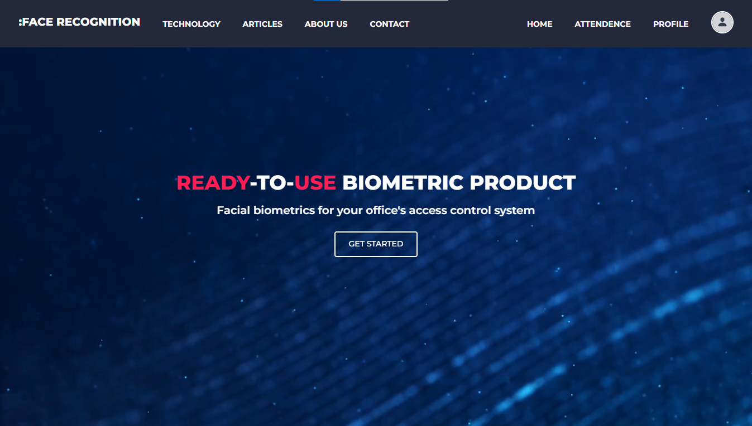

Figure . – Homepage of User Interface

In figure 3.6 is Homepage for Admin, you can choose quick options of pages by clicking on the card or selecting in the left sidebar.

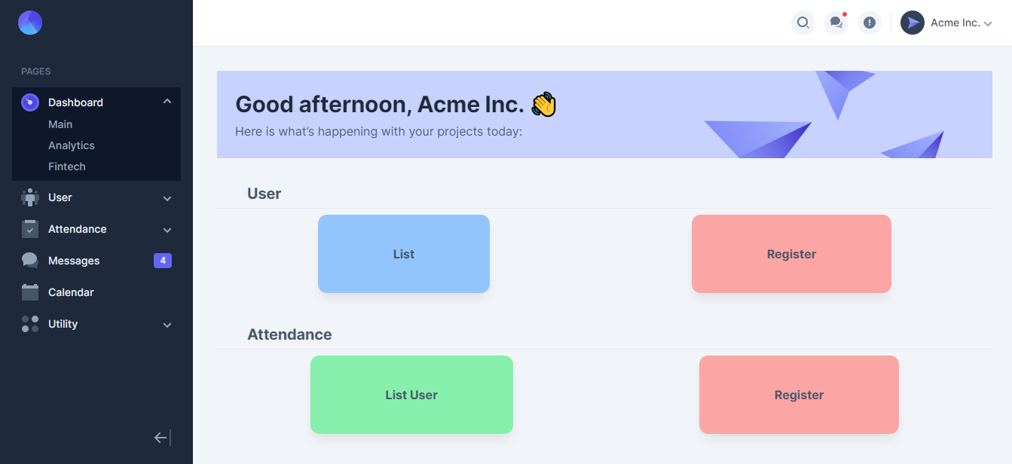

Figure . – Homepage Admin

In figure 3.7 is list User, you can delete and edit

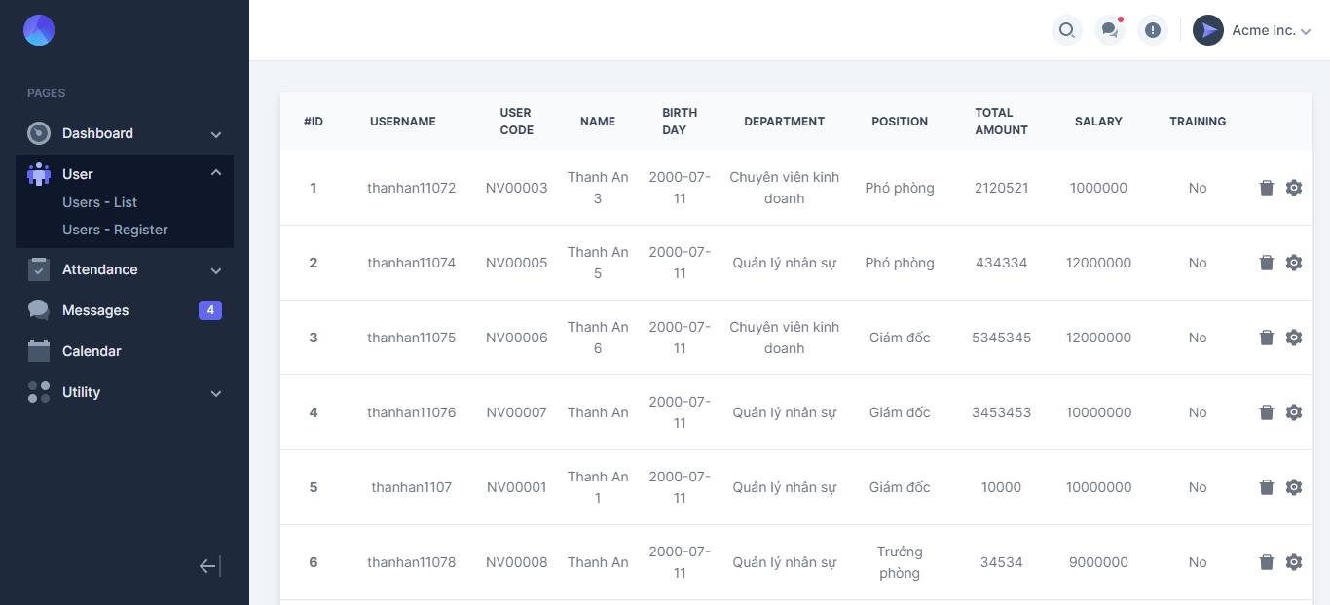

Figure . – List user

CONCLUSIONS AND SUGGESTIONS

Conclusions

Through this thesis, we have contributed a new approach to the problem face detection. Besides, the promise of opening a new kind of feature has developed for determining the position of facial features such as eyes, nose, mouth, etc. In addition, it can be expanded to become an identification problem face

We have learned the problem of detecting human faces based on 3D concave features to recognize faces and identify specific applications human face detection. From there, we built a human identification system

The program that detects the human face in the photo has recognized the face and facial details. In order to provide practical applications in modern life:

Suggestions

The program that detects the human face in the image has recognized the face and its details. In order to bring practical applications in modern life:

Emotion analysis of human face

Organize searches related to people through faces on many large database systems

Control access to agencies and offices

System of observation, tracking and protection

Entertainment

Crime identification

Intelligent human-machine communication system

Citizen management through facial indicators

REFERENCES

Website:

Stackoverflow.com

Google.com

Github.com

W3schools.com

colab.research.google.com

Reference books:

Digital Image Processing FOURTH EDITION Rafael C. Gonzalez • Richard E. Woods

Digital Signal Processing Principles, Algorithms, and Applications Third Edition John G. Proakis Northeastern University Dimitris G. Manolakis Boston College

Hands-on Machine Learning with Scikit-Learn, Keras & TensorFlow – Concepts, Tools, and Techniques to Build Intelligent Systems